Alexander Cannell

CSIS 2600

1/12/12

Project 1-1

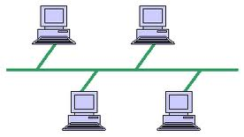

1. It would be the same pathway but with different permissions.

3.

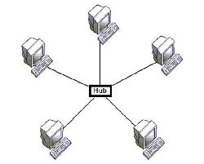

1. It would be the same pathway but with different permissions.

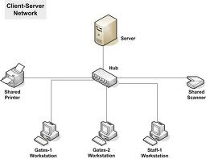

1. G goes to the hub then to the printer, and the printer prints the document.



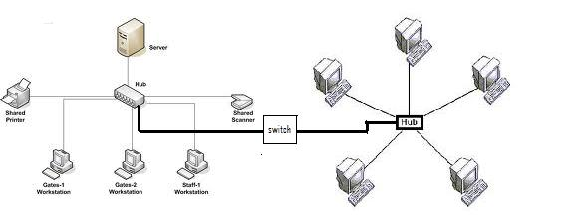

1. Allow the J workstation permissions for the printer (which will probably mean adding the printer from the J workstation, or adding the drivers on the J workstation) on the server from the client/server network.
2. The easiest is the client/server connection because you can control all the permissions from the server rather than going to individual computers.
3. Least expensive would be the peer to peer connection.

Project 1-2

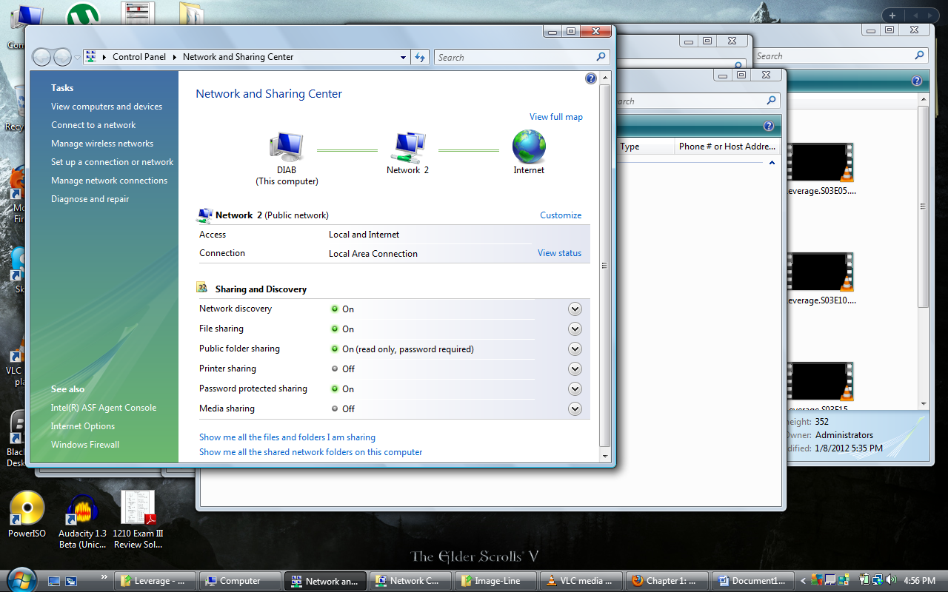

I enabled my sharing of documents on my network. (even though my computer is the only one on the network.

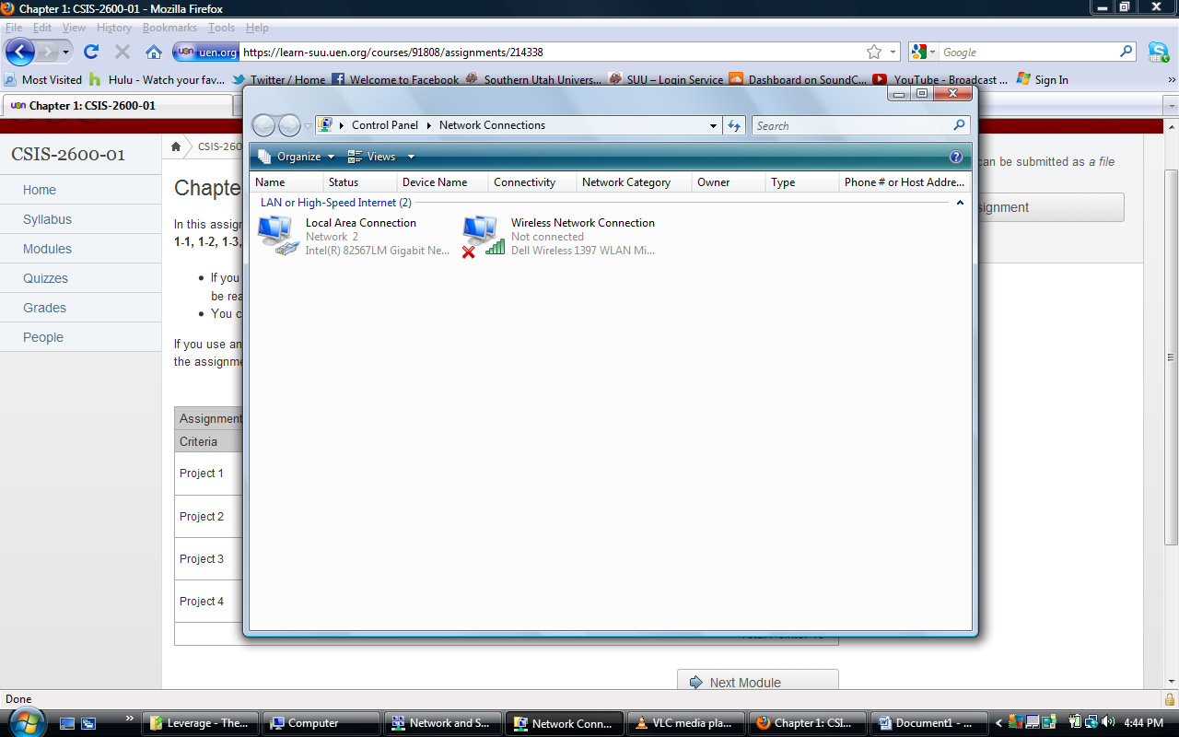

Ok well I connected my station to the network enabling my internet too.

Project 1-3

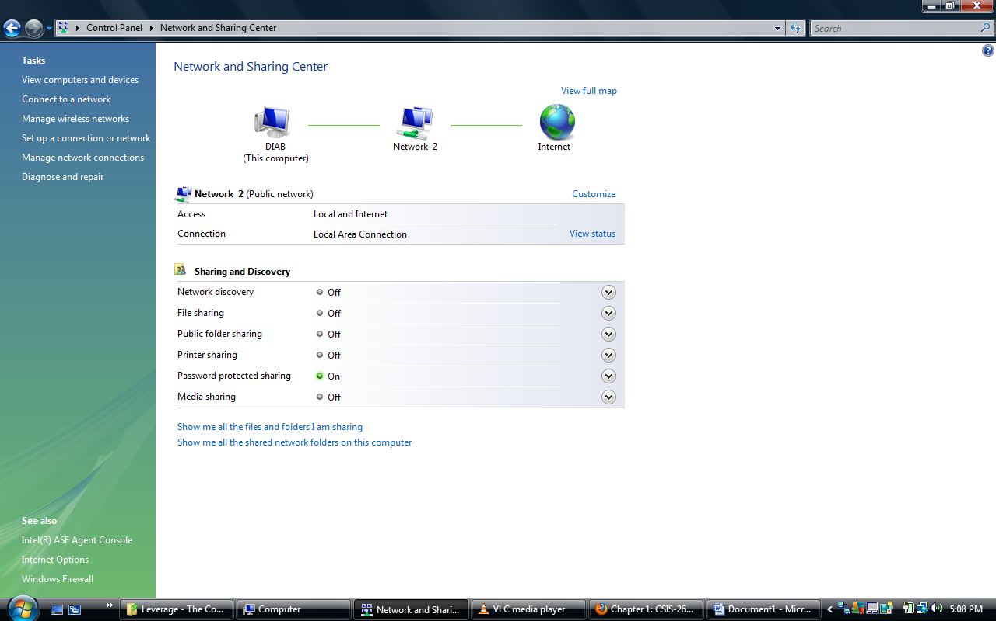

Well for this one I turned oh sharing allowing everyone on the network to access my open files, and made sure I was connected to a private network, turned off file sharing.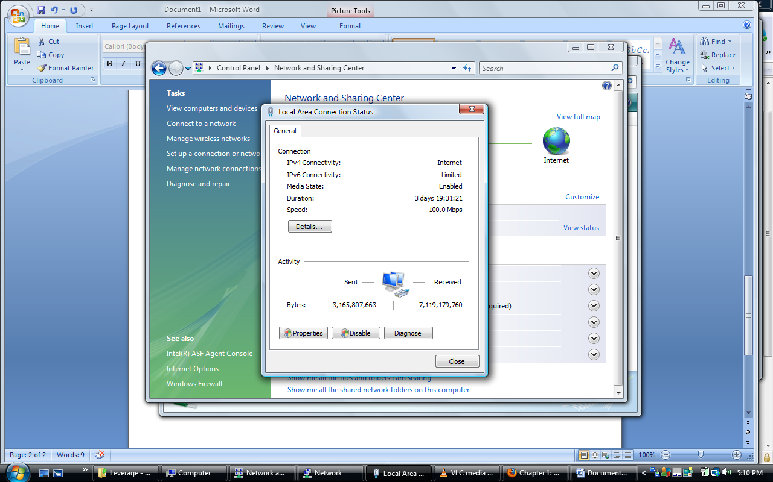

This shows my connectivity to my local area network, and shows that I know how to get to the network status page, to tweak the IP properties.

Project 1-4

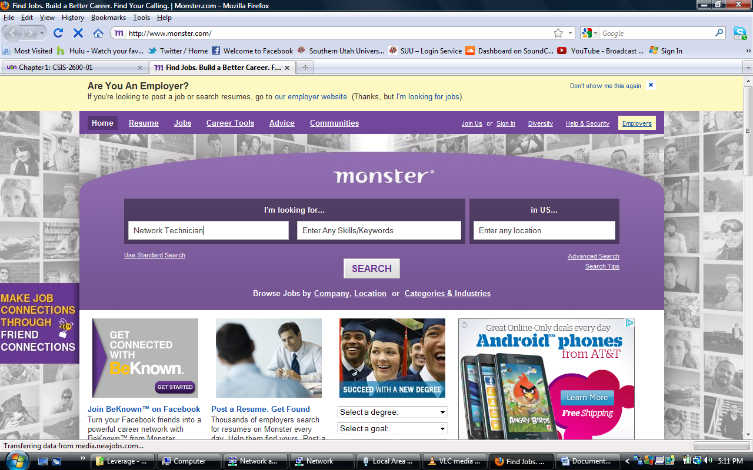

There were no network technician jobs within 100miles, 95 results in the United States. So, I found one in New York, at pinnical.

<http://jobview.monster.com/Network-Technician-CCNA-CCNP-Job-Fishkill-NY-105536948.aspx>

There were no network manager jobs within 100miles, 142 results in the United States. So, I found one at Brooklyn New York.

<http://jobview.monster.com/Voice-Data-Network-Manager-Job-Brooklyn-NY-105615146.aspx>

There were no IT/Software Development jobs within 100miles, 142 results in the United States. So, I found one at New York.

<http://jobview.monster.com/Sr-J2EE-Programmer-for-IT-commodities-firm-in-Stamford-CT-130k-Job-Westport-CT-105538744.aspx>